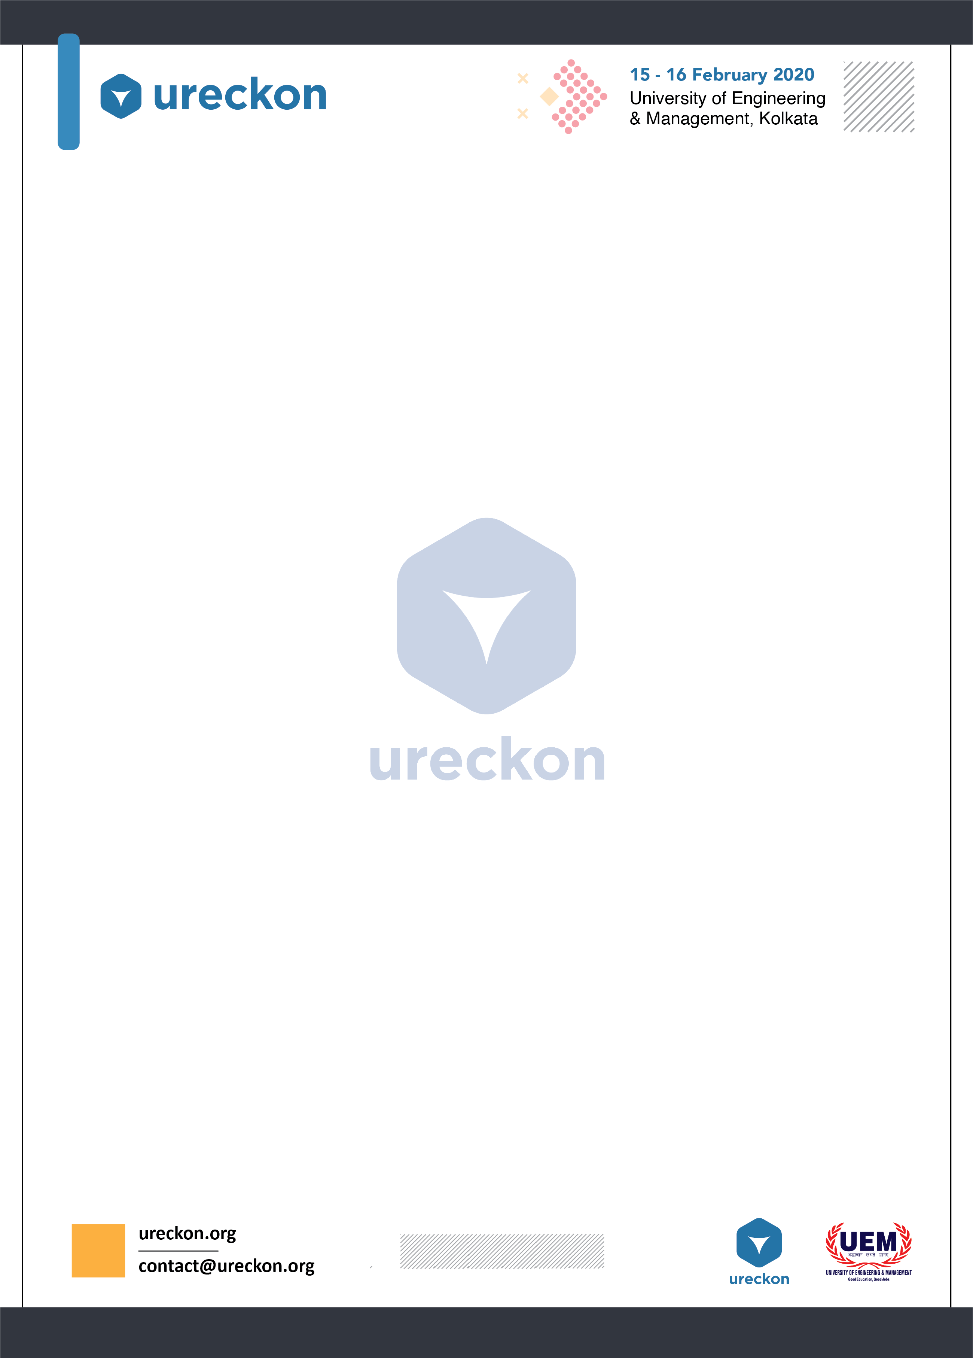

URECKA

**INTRODUCTION:**

Ureckon is a platform where you can showcase your innovative talent in front of Defence Research and Development Organisation (**DRDO**) and later on you may get a chance to do project in collaboration with DRDO. Nothing is more important than your imaginations and creativity. This is the biggest platform to implement your ideas, thoughts and imaginations into reality. “You make one prototype model to showcase and present your idea in front of the tech-world”.

**PROBLEM STATEMENT:**

In this event, the participants have to demonstrate their models to the judges. Winner will be decided as per the marking of the respected judges.

**RULES & REGULATIONS:**

1.A team can have maximum five members.(Atleast one Member of the team

must be present everytime with the model)

2.Team members may be from same or different school.

3.Each member of a group must be present during the model presentation.

4.Each team must have their own equipments. No electronic components

will be provided.

5.Each team must bring their own model with a description chart (model

name, model description, utility etc.)

6.Each team will demonstrate their model to the judges for

evaluation.

**DAY WISE EVENT DETAILS:**

**Section 1:**

1.Judges will be visiting to analyse your models.

2.School students will be coming as well to look at your innovative models.

3.You need to demonstrate your projects to our honourable judges.

**Section 2:**

1. Judges will be visiting to analyse your models.

2.School students will be coming as well to look at your innovative models.

3.You need to demonstrate your projects to our honourable judges.

4.Winners will be decided according to the markings of our respected judges.

**Judgement Details:**

Your idea will be judged on the basis of:

* Originality: Whether your idea is self-inspired
* Feasibility: Whether your idea can be brought to life and be implemented
* Impact: Whether your idea can have a real impact or bring about a change in the society
* Scalability: Whether your idea could be scaled from the smallest level to the largest level

**Disclaimer: Rules are subjected to change without any prior information**

**Event Coordinators:**

**Arpan Chatterjee (+917044196266)**

**Chandan Kumar Singh(+919163036910)**

**Abhishek Jaiswal(+918910924144)**

